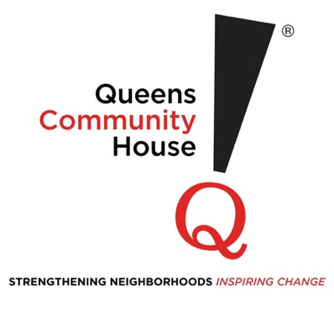
Appe
Will you be there for Queens ?

November 15, 2024

Name
Address Line 1
Address Line 2
City, State, Zip
Hello XXXX,
As someone who believes in the power of community, you understand that sometimes, even the strongest among us need a helping hand.
As we close another year, I want to share a story that captures the mission and heart of Queens Community House (QCH).
Today, I'm asking you to join us in creating more success stories like Daniel's—a young man whose life took a difficult turn before he found hope at QCH.
Would you consider a gift this season of $25, $50, $100, $250, $500, or whatever amount feels meaningful to you?
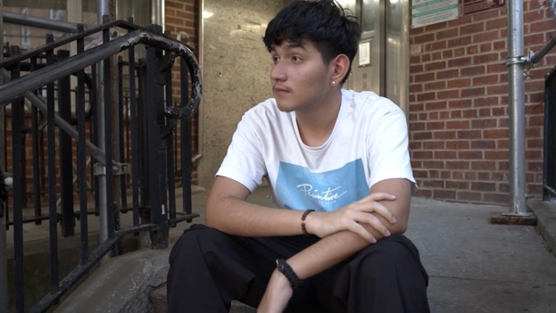
Together, we can help more people bounce back from hard times.
Daniel's parents left Colombia twenty years ago, dreaming of a better future in America. They built a warm, loving home in Queens where Daniel thrived—until his father's devastating heart attack during Daniel's first year of high school.
Watching his father's health deteriorate, Daniel's world began to unravel.
His attendance dropped, his grades suffered, and eventually, he stopped going to school altogether.
One day, his mother—determined to keep her son from drifting further away—came across a QCH brochure and called us immediately.
Soon after, Daniel enrolled at Voyages High School, one of QCH's five alternative high schools dedicated to giving young people a second chance at success.

During his transition, Daniel's father tragically passed away, leaving him devastated.
But our QCH staff stood by him, offering him the support, guidance, and safe space he needed to grieve, heal, and find the internal strength to move forward.
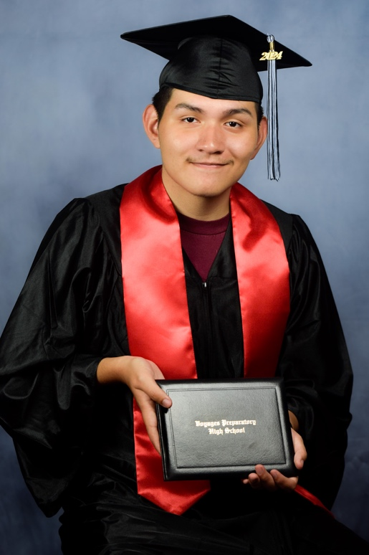
Day by day, Daniel began to rediscover his confidence. He formed close bonds with his teachers and classmates, and slowly, the world felt less overwhelming. The caring community at Voyages showed him he wasn't alone.
The day Daniel graduated (with honors), his mother's tears of joy spoke volumes.
Today, he's excelling at Borough of Manhattan Community College, building the future his parents dreamed of for him.
His journey wouldn't have been possible without the generosity of caring people like you, who believe in lifting up our neighbors and providing them with the resources they need to overcome life's toughest challenges.
When you support QCH, you invest in more than individual success stories.
You're strengthening the fabric of our community, creating a safety net that catches people when they fall and lifts them back up.
Your donation of $25, $50, $100, $250, or more will allow us to be there for those who need it most.
Please take a moment today to renew your support. Your gift will bring hope and opportunity to countless others who are still struggling.
With deepest gratitude,
Ben Thomases
Executive Director
P.S. Your generosity powers everything we do. Giving to QCH by December 31 will help ensure more stories like Daniel's have happy endings. Thank you for being part of our community of change-makers.

